Embedded Payment Form
# Source: AI Source: Provided by: [Data Path: Persons Table -> ID Column: 1, Name_En Column: Motasem Essam] -> From: [ChatGPT] on [1/21/2026]
An Embedded Payment Form is a payment interface built directly into your website or app — often using a JavaScript SDK or iframe provided by the payment gateway. It allows customers to enter their payment details without being redirected to an external page.

🧠 Simple Definition
# Source: AI Source: Provided by: [Data Path: Persons Table -> ID Column: 1, Name_En Column: Motasem Essam] -> From: [ChatGPT] on [1/21/2026]
An Embedded Form lets you display secure payment fields (e.g., card number, CVV) inside your site, while still relying on the payment gateway to process the data behind the scenes.

🔧 How It Works
# Source: AI Source: Provided by: [Data Path: Persons Table -> ID Column: 1, Name_En Column: Motasem Essam] -> From: [ChatGPT] on [1/21/2026]
- You embed secure input fields (via iframe or JavaScript SDK) into your checkout page.
- The user enters card or payment info without leaving your site.
- The sensitive data is tokenized by the gateway (not handled by your backend).
- Your server sends the token to the gateway API to complete the transaction.
- You display the payment result (success/failure) immediately on your page.

🛡️ Security: Who Handles What?
# Source: AI Source: Provided by: [Data Path: Persons Table -> ID Column: 1, Name_En Column: Motasem Essam] -> From: [ChatGPT] on [1/21/2026]
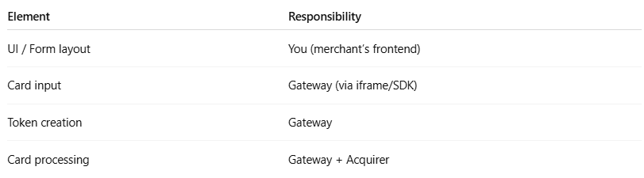

Element | Responsibility
UI / Form layout | You (merchant’s frontend)
Card input | Gateway (via iframe/SDK)
Token creation | Gateway
Card processing | Gateway + Acquirer
⚠️ You don’t touch card data directly — that’s handled by the iframe/JS SDK.

💡 Why Use an Embedded Form?
# Source: AI Source: Provided by: [Data Path: Persons Table -> ID Column: 1, Name_En Column: Motasem Essam] -> From: [ChatGPT] on [1/21/2026]
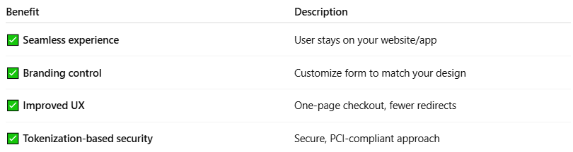

Benefit | Description
✅ Seamless experience | User stays on your website/app
✅ Branding control | Customize form to match your design
✅ Improved UX | One-page checkout, fewer redirects
✅ Tokenization-based security | Secure, PCI-compliant approach

🔁 Example Flow
# Source: AI Source: Provided by: [Data Path: Persons Table -> ID Column: 1, Name_En Column: Motasem Essam] -> From: [ChatGPT] on [1/21/2026]
- Use the gateway’s JS SDK (e.g., Stripe.js, Paymob's iframe).
- Gateway inserts a secure card field on your checkout page.
- User enters card info → gateway returns a payment token.
- Your backend sends the token to gateway API to finalize the payment.
- You show confirmation without a page reload or redirect.

🖼️ Visualization
# Source: AI Source: Provided by: [Data Path: Persons Table -> ID Column: 1, Name_En Column: Motasem Essam] -> From: [ChatGPT] on [1/21/2026]
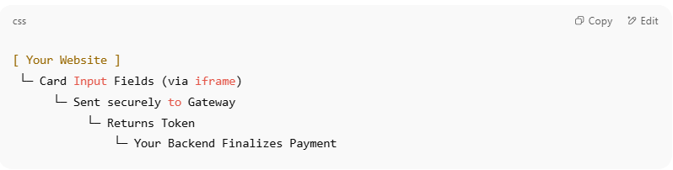

[ Your Website ]
└─ Card Input Fields (via iframe)
└─ Sent securely to Gateway
└─ Returns Token
└─ Your Backend Finalizes Payment

❗ Challenges to Consider
# Source: AI Source: Provided by: [Data Path: Persons Table -> ID Column: 1, Name_En Column: Motasem Essam] -> From: [ChatGPT] on [1/21/2026]
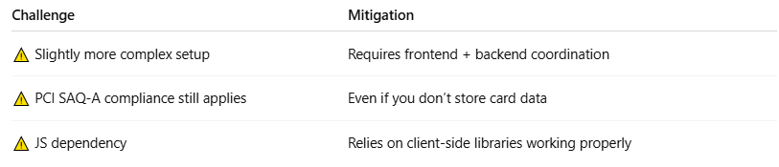

Challenge | Mitigation
⚠️ Slightly more complex setup | Requires frontend + backend coordination
⚠️ PCI SAQ-A compliance still applies | Even if you don’t store card data
⚠️ JS dependency | Relies on client-side libraries working properly

📦 Examples of Gateways Offering Embedded Forms
# Source: AI Source: Provided by: [Data Path: Persons Table -> ID Column: 1, Name_En Column: Motasem Essam] -> From: [ChatGPT] on [1/21/2026]
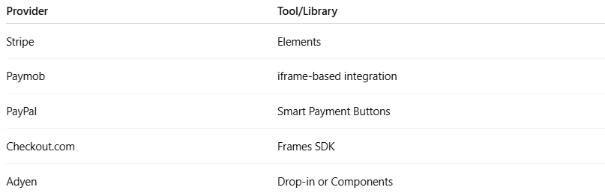

Provider | Tool/Library
Stripe | Elements
Paymob | iframe-based integration
PayPal | Smart Payment Buttons
Checkout.com | Frames SDK
Adyen | Drop-in or Components

📌 Summary
# Source: AI Source: Provided by: [Data Path: Persons Table -> ID Column: 1, Name_En Column: Motasem Essam] -> From: [ChatGPT] on [1/21/2026]
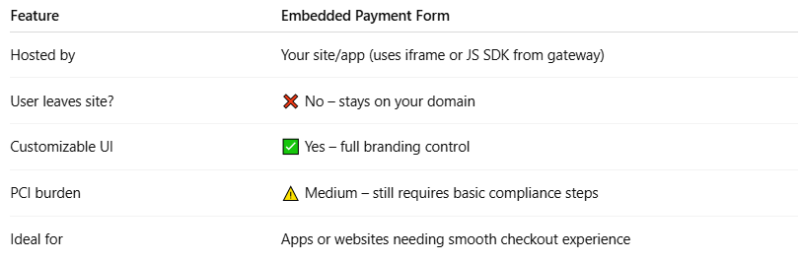

Feature | Embedded Payment Form
Hosted by | Your site/app (uses iframe or JS SDK from gateway)
User leaves site? | ❌ No – stays on your domain
Customizable UI | ✅ Yes – full branding control
PCI burden | ⚠️ Medium – still requires basic compliance steps
Ideal for | Apps or websites needing smooth checkout experience

